Project Development Phase Sprint 1

|  |  |
| --- | --- |
| Date | 19 November 2022 |
| Team ID | PNT2022TMID27784 |
| Project Name | AI Based Discourse for Banking Industry |

# Create IBM Watson Assistant Service & Chatbot Skills

**Creation of IBM Watson Assistant Service:**

To implement AI Based Discourse for Banking Industry, we need an IBM Service. The Service used is **IBM WATSON ASSISTANT.**

|  |  |
| --- | --- |
| **IBM SERVICE** | **WATSON ASSISTANT** |
| **REGION** | **DALLAS** |
| **LANGUAGE** | **ENGLISH** |

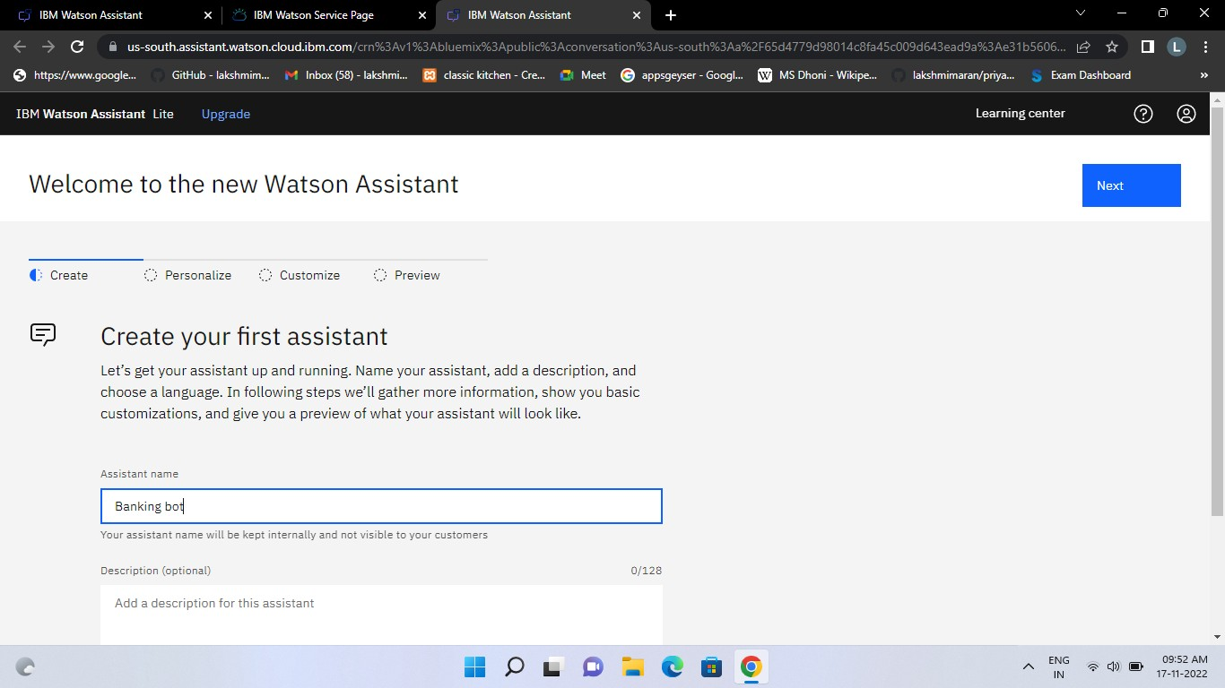

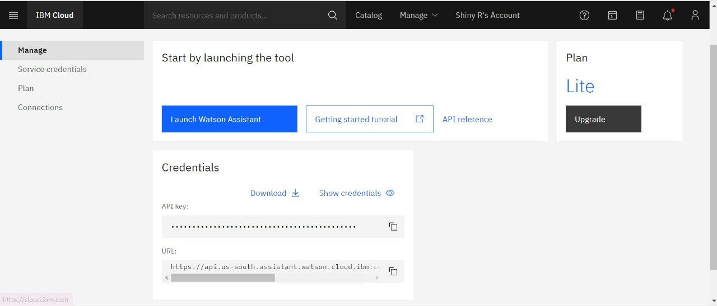

# Creation of Chatbot Skills:

Skills are nothing but actions and steps. Steps are the subset of actions where conversations are built and Assistant is used to integrating skills.

The Chatbot build for the project AI Based Discourse for Banking Industry is based on **ACTION SKILLS.**

|  |  |
| --- | --- |
| **SKILL TYPE** | **ACTION OR STEP SKILL** |
| **LANGUAGE** | **ENGLISH** |



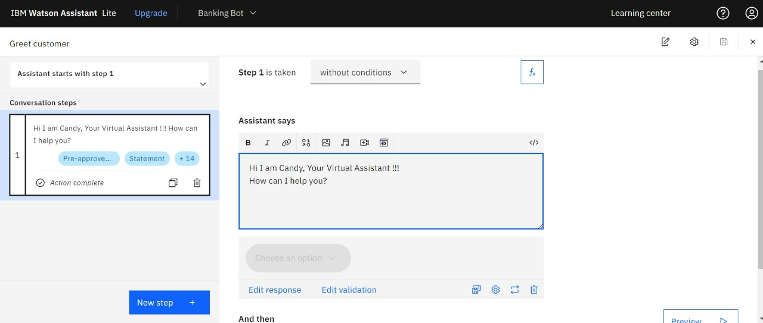

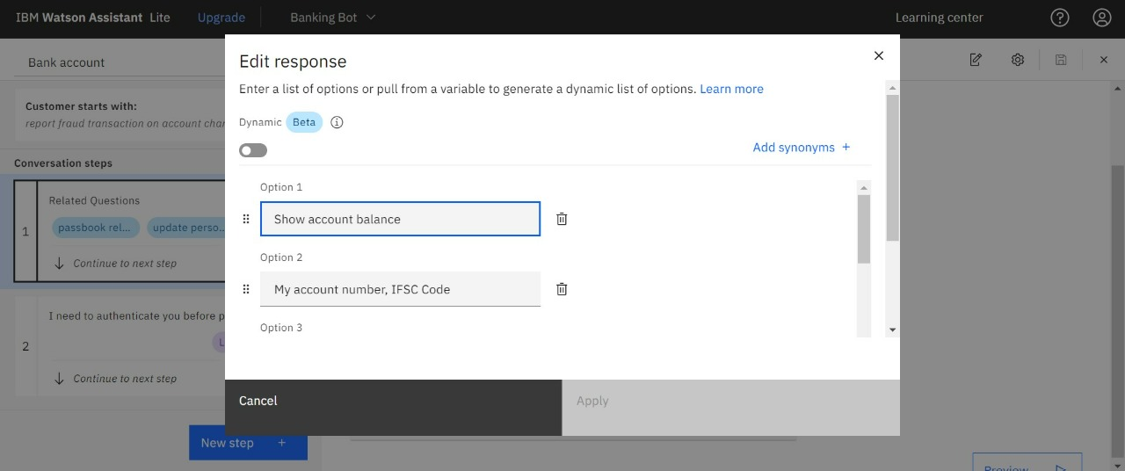

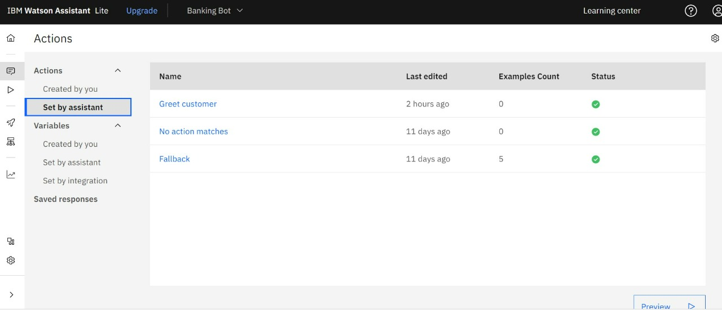

**Note: In this Sprint 1, there is no code needed to create assistant and skills, it purely based on Actions and steps.**